

**Soft Computing IA2 report**

Submitted

by

**Rohit Sattendra Deshpande**

Roll No: 16010122041

Class- TY COMPS A

**Department of Computer Engineering**

**K. J. Somaiya College of Engineering**

**(Constituent College of Somaiya Vidyavihar University)**

**Table Of Contents**

**List of Figures…………………………………………………………………………………….2**

**List of Tables……………………………………………………………………………………...2**

**Chapter 1: CNN-Based Image Quality Classification Considering Quality Degradation in Bridge Inspection Using an Unmanned Aerial Vehicle………………………………………..3**

Introduction………………………………………………………………………………………..3

Methodology………………………………………………………………………………………3

Hardware and Software……………………………………………………………………………4

Experimental Analysis and Validation…………………………………………………………….5

Conclusion………………………………………………………………………………………...6

**Chapter 2: Fuzzy Logic and Decision Making Applied to Customer Service Optimization..8**

Introduction………………………………………………………………………………………..8

Customer Service Analysis and Optimization: Literature Review………………………………..8

Hardware and Software……………………………………………………………………………8

Methodology………………………………………………………………………………………9

VIUE Model……………………………………………………………………………………….9

Conclusion……………………………………………………………………………………….10

**Chapter 3: Predicting Stock Market Trends Using Machine Learning and Deep Learning Algorithms Via Continuous and Binary Data: A Comparative Analysis…………………...11**

Introduction………………………………………………………………………………………11

Hardware and Software…………………………………………………………………………..11

Methodology……………………………………………………………………………………..11

Experimental Analysis…………………………………………………………………………...12

Conclusion……………………………………………………………………………………….15

**References and Citations……………………………………………………………………….16**

**List of Figures**

**Chapter 1: Chapter 1: CNN-Based Image Quality Classification Considering Quality Degradation in Bridge Inspection Using an Unmanned Aerial Vehicle**

**Figure 1:** Flowchart for the proposed methodology………………………………………………………..5

**Figure 2:** Schematic diagram of CNN-based IQA architecture using the VCG-16 for transfer learning……………………………………………………………………………………………………...6

**Chapter 2: Fuzzy Logic and Decision Making Applied to Customer Service Optimization**

**Figure 1:** VIUE Model……………………………………………………………………………………11

**Chapter 3: Predicting Stock Market Trends Using Machine Learning and Deep Learning Algorithms Via Continuous and Binary Data: A Comparative Analysis**

**Figure 1:** Average of F1-Score based on average logarithmic running per sample for continuous data………………………………………………………………………………………………………...15

**Figure 2:** Average of F1-Score based on average logarithmic running per sample for binary data………16

**List of Tables**

**Chapter 1: Chapter 1: CNN-Based Image Quality Classification Considering Quality Degradation in Bridge Inspection Using an Unmanned Aerial Vehicle**

**Table 1:** Classification performance indicators for validation 1…………………………………………...8

**Table 2:** Classification performance indicators for validation 2…………………………………………...8

**Chapter 2: Fuzzy Logic and Decision Making Applied to Customer Service Optimization**

(No Tables)

**Chapter 3: Predicting Stock Market Trends Using Machine Learning and Deep Learning Algorithms Via Continuous and Binary Data: A Comparative Analysis**

**Table 1:** Neural-network based models with best parameter for continuous data………………………...15

**Table 2:** Tree-based models with best parameters for binary data………………………………………..15

**Chapter 1:**

**CNN-Based Image Quality Classification Considering Quality Degradation in Bridge Inspection Using an Unmanned Aerial Vehicle**

**Introduction**

The use of Unmanned Aerial Vehicles (UAVs) for bridge inspections has revolutionized structural health monitoring. UAVs provide enhanced accessibility, reduced costs, and improved safety compared to traditional manual inspections. However, consistent image quality remains a significant challenge in ensuring reliable damage detection. Factors like motion blur, underexposure, overexposure, and focus issues—often arising from UAV movement, environmental conditions, and camera settings—can degrade image quality, leading to incorrect structural assessments.

This research proposes an Image Quality Assessment (IQA) method using Convolutional Neural Networks (CNNs) to address image degradation. The study’s goals are twofold:

1. **Establish a methodology** to maintain consistent image quality during UAV-based bridge inspections by optimizing camera settings.
2. **Develop a CNN-based IQA model** capable of evaluating and classifying images affected by multiple distortions, achieving performance comparable to human assessment while providing faster processing times.

This approach contributes to more reliable structural assessments by addressing quality issues and automating the evaluation process.

**Methodology**

The proposed methodology for IQA using CNNs consists of two primary stages:

**Stage 1: Image Acquisition with Quality Considerations** In the first stage, UAVs are utilized to capture structural inspection images with settings adjusted to minimize image degradation. Key parameters for image quality include:

* **External Factors:** UAV speed, environmental illumination
* **Internal Camera Factors:** Aperture, shutter speed, and ISO settings

By carefully controlling these factors, the goal is to avoid common quality issues such as motion blur, underexposure, overexposure, and out-of-focus images. The inspection image quality is adjusted to ensure that high-quality images are consistently acquired.

**Stage 2: CNN-Based Image Quality Classification** In the second stage, a CNN-based model is trained using the dataset prepared in the first stage. The model classifies images into two categories: high-quality and low-quality. The training process utilizes 90% of the labeled dataset, while the remaining 10% is reserved for validation.

* **High-Quality Images:** Sharpened images with clear boundaries
* **Low-Quality Images:** Images with motion blur, underexposure, overexposure, or out-of-focus issues

The trained CNN model can then be applied to new inspection datasets to classify image quality automatically. This ensures that low-quality images can be identified and isolated, improving the accuracy and efficiency of structural inspections

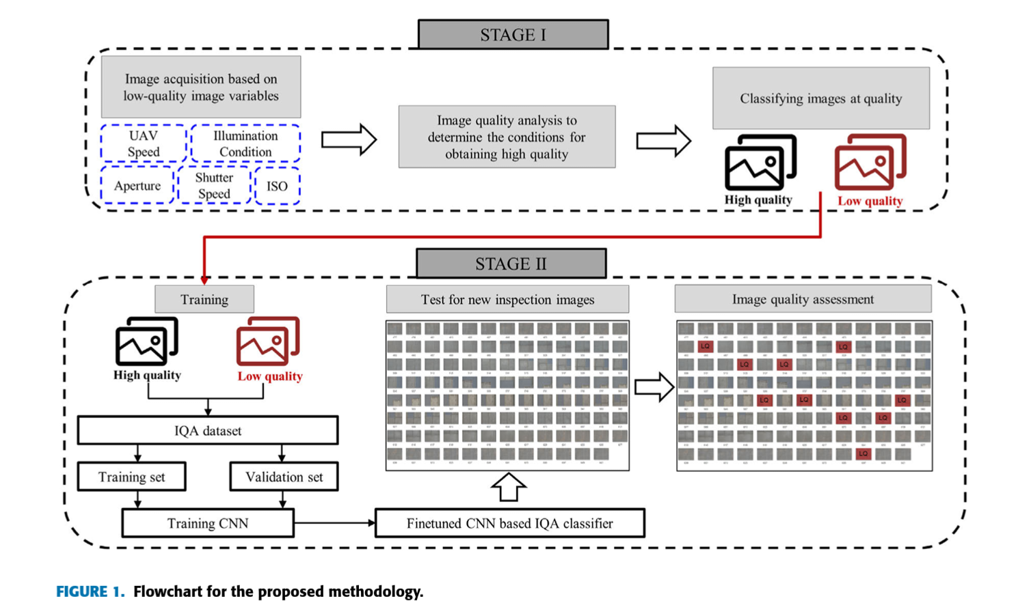.

### Hardware and Software

**Hardware**

* UAV System: DJI Inspire 2 UAV
* Camera: Zenmuse X7 camera with a 35mm fixed lens
* UAV Speed: Flight speeds ranged from 1 m/s to 4 m/s
* Camera Settings:
  + Shutter Speed: Varied from 1/100s to 1/8000s
  + Aperture: Set between F/5.6 and F/8
  + ISO Settings: Adjusted to handle exposure problems

**Software**

* Convolutional Neural Network (CNN): Built using VGG-16 architecture
* Training Data: Dataset of 11,990 images
* Transfer Learning: VGG-16 pre-trained on ImageNet for feature extraction, with fine-tuning for quality classification
* Training and Validation: Model training and validation peaked in performance at the 10th epoch.

**Experimental Analysis and Validation**

The proposed CNN-based IQA method was experimentally validated using datasets acquired by UAVs during bridge inspections. These validation datasets were not used during model training, ensuring a reliable evaluation of the CNN-based classifier's performance.

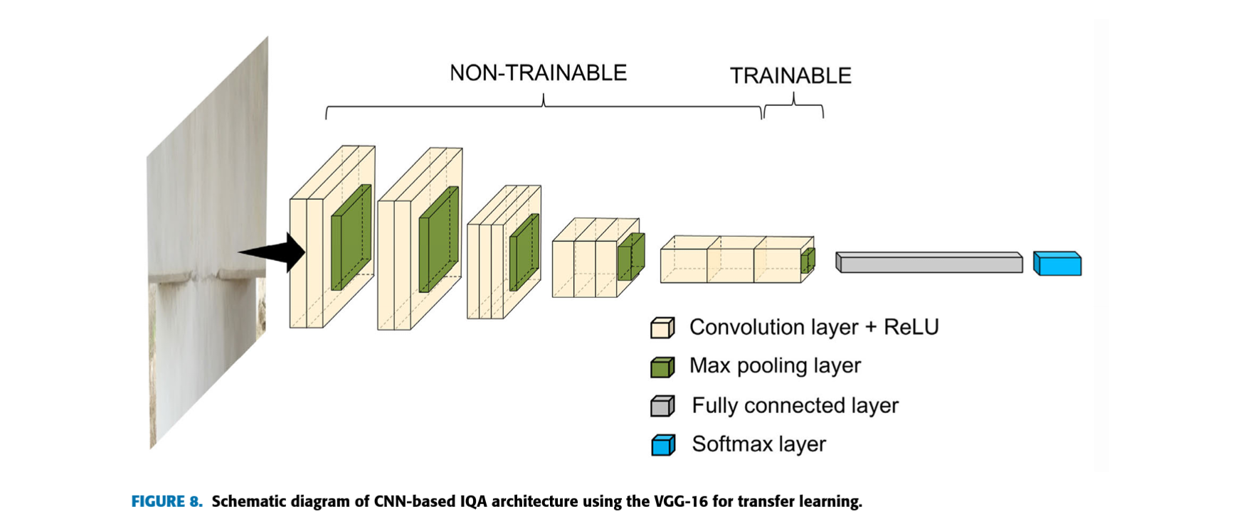

**Two experimental validation cases were conducted:**

1. **Validation using images with exposure issues:** The CNN model was tested on images with varying exposure levels. The results were compared with human visual inspections using the Mean Opinion Score (MOS) method and a traditional NR-IQA approach (PIQUE).
2. **Validation using images with motion blur issues:** A new dataset was collected to evaluate the model's performance on motion-blurred images. The CNN model's results were again compared with MOS and a traditional NR-IQA method (SGV).

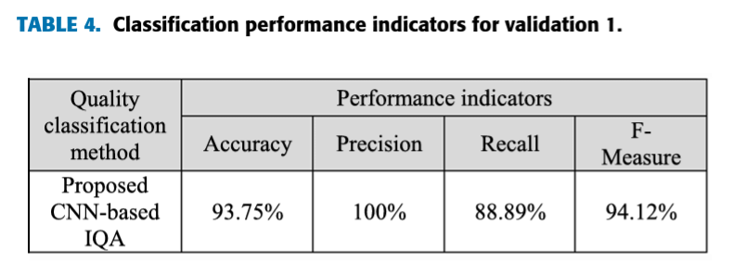

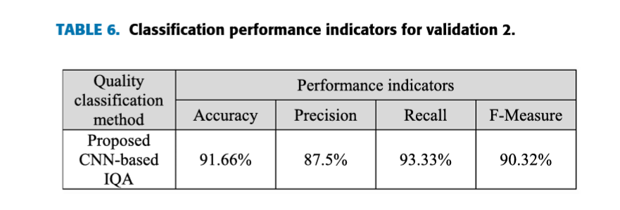

**Key findings from the experimental analysis:**

* The CNN-based IQA model demonstrated strong performance in classifying image quality, closely aligning with human visual assessments.
* The model outperformed traditional NR-IQA methods, particularly for mid-range distortions.
* The CNN model effectively identified images with exposure issues and motion blur.
* Despite processing challenges, the method offers clear advantages for bridge inspection by improving 3D modeling and structural evaluations.

**Conclusion**

This research introduced a CNN-based IQA method for classifying images acquired during UAV-based bridge inspections. The proposed framework effectively addressed image quality degradation issues, including motion blur, exposure, and focus problems. The CNN model demonstrated strong performance in classifying image quality, aligning closely with human visual assessments. The method offers potential benefits for improving the efficiency and accuracy of bridge inspections by isolating low-quality images.

**Future research could focus on:**

* Refining the methodology to evaluate the severity of image degradation.
* Developing image enhancement techniques to recover low-quality images.
* Addressing additional challenges, such as shadows and physical obstructions.

By addressing these areas, the CNN-based IQA method can be further improved and applied more effectively in practical applications.

**Chapter 2:**

**Fuzzy Logic and Decision Making Applied to Customer Service Optimization**

**Introduction**

The continuous advancement of digital transformation has made customer service a fundamental pillar for companies. With access to comprehensive customer data, organizations can now leverage sophisticated analytics to optimize their customer interactions. While traditional models like RFM (Recency, Frequency, Monetary) and Customer Lifetime Value (CLV) provide valuable insights, modern customer service demands a more nuanced approach that considers multiple factors beyond transactional data.

This research introduces an enhanced methodology that combines the existing RFID model (Recency, Frequency, Importance, Duration) with additional factors such as Impact, Urgency, and Emotional character of interactions (VIUE). By incorporating Waiting Time and Contact Center Workload considerations, this study presents a dynamic, real-time prioritization system for customer interactions. The proposed approach utilizes fuzzy logic and the Analytic Hierarchy Process (AHP) to unify heterogeneous information through 2-tuple linguistic evaluations, ultimately enabling more effective customer service optimization.

**Customer Service Analysis and Optimization: Literature Review**

The existing research in customer service optimization can be categorized into three main streams:

1. **Customer Satisfaction Measurement:** Traditional metrics like Net Promoter Score (NPS) and Customer Effort Score (CES) have been widely adopted. However, recent research suggests that a 360-degree approach incorporating multiple metrics provides more reliable insights into customer behavior patterns.
2. **Customer Segmentation and RFM Analysis:** While various data mining techniques have been employed for customer segmentation, RFM models remain prevalent due to their interpretability and actionable insights. However, there is a notable gap in research specifically addressing customer ratings from a Contact Center perspective.
3. **Fuzzy Logic in Contact Center Operations:** Research applying fuzzy logic to Contact Center operations is limited, with only a few significant studies identified. The literature reveals a significant research gap in dynamic prioritization of customer interactions, with most existing studies focusing on basic routing and queue management.

**Hardware and Software**

**Hardware:** High-performance servers for fast processing speeds and parallel computing to handle multiple interactions simultaneously.

**Software:** Customer Relationship Management (CRM) system, Contact Center tool, advanced data analytics tools for fuzzy logic and AHP.

**Methodology**The study integrated three primary theoretical frameworks: the 2-tuple linguistic model (LD2T), the Analytic Hierarchy Process (AHP), and Heterogeneous information treatment.

**2-Tuple Linguistic Model (LD2T):**

* Represents linguistic terms as paired values (sᵢ, αᵢ).
* Uses triangular membership functions for linguistic domain representation.
* Incorporates transformation functions ΔS and Δ⁻¹S for numerical-linguistic conversions.

**Analytic Hierarchy Process (AHP):**

* Provides a structured approach for complex decision-making.
* Involves pairwise comparisons and consistency checks.
* Uses Saaty's scale for comparisons and the Consistency Ratio (CR) for evaluation.

**Heterogeneous Information Treatment:**

* Addresses the challenge of unifying diverse information types.
* Employs TNS, TIS, and TSS functions for numerical, interval, and linguistic domain transformations.

**VIUE Model**

The VIUE model is a sophisticated framework designed to enhance contact center operations by prioritizing and personalizing customer interactions. Key components include:

* **Interaction Classification:** Categorizes interactions based on value, impact, urgency, and emotional nature.
* **Priority Determination:** Calculates a composite score to prioritize interactions.
* **Contextual VIUE:** Considers SLAs and contact center workload for dynamic prioritization.
* **Parameter Determination:** Expert input guides the model's parameters.

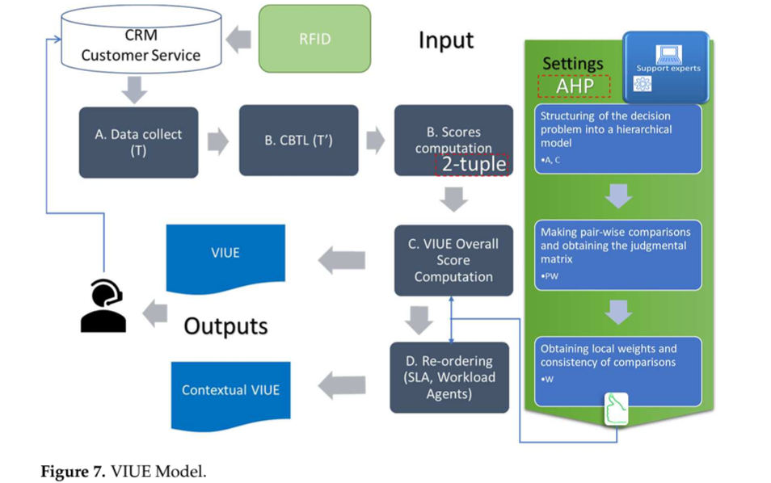

**Process Flow:**

1. Data collection from CRM systems.
2. Definition and computation of CBTL domains.
3. Calculation of overall VIUE scores.
4. Reordering of interactions based on contextual VIUE.
5. Recommendations for personalized responses.

**VIUE Model in B2B Software Licensing** The VIUE model was applied in a B2B software licensing manufacturer. Interactions were analyzed, categorized, and prioritized using the VIUE framework. The AHP model assigned weights to criteria, and interactions were reordered based on priority scores, waiting time, workload, and SLAs.

**Conclusion**

The VIUE model offers a significant advancement in customer service optimization by providing a comprehensive and dynamic approach to interaction prioritization. It integrates RFID metrics, VIUE factors, and AHP to enable more effective customer service management. Future research could focus on refining the VIUE model, exploring additional factors, and applying it in various business sectors.

**Chapter 3:**

**Predicting Stock Market Trends Using Machine Learning and Deep Learning Algorithms Via Continuous and Binary Data: A Comparative Analysis**

**Introduction**

Accurately predicting stock market trends is a complex challenge due to the numerous factors influencing market movements. This study explores the potential of machine learning (ML) and deep learning (DL) techniques to improve stock trend forecasting. It compares the performance of various algorithms in predicting the trends of four groups listed on the Tehran Stock Exchange (TSE): diversified financials, petroleum, non-metallic minerals, and basic metals.

**Hardware and Software**

* **Hardware:**
  + The study doesn't specify exact configurations, but deep learning models require substantial processing power. High-performance CPUs and GPUs are ideal, especially for large datasets.
  + Sufficient RAM (at least 16GB) is crucial for time-series data processing and deep learning model training.
  + GPUs with support for libraries like CUDA (NVIDIA GPUs) significantly accelerate deep learning model training (RNNs and LSTMs).
* **Software:**
  + Python 3: Used for coding and model implementation.
  + Libraries:
    - Scikit-Learn: A popular library for building classical ML models (Decision Tree, Random Forest, etc.).
    - Keras: A deep learning library for constructing neural network models (ANN, RNN, LSTM).
    - TensorFlow or Theano (backend for Keras): Supports deep learning algorithms.
  + Operating System: Typically Linux or Windows.

**Methodology**

**Data Acquisition and Preprocessing**

The study utilized ten years of historical data (November 2009 - November 2019) for the four selected stock market groups obtained. Two data representation methods were explored for model input: continuous and binary data.

**Continuous Data Approach**

Ten technical indicators (SMA, WMA, MOM, STCK, STCD, LWR, MACD, ADO, RSI, and CCI) were calculated based on historical stock prices (open, close, high, and low values). These indicators were normalized within the range (0, +1) for better comparison across different scales.

**Binary Data Approach**

Continuous indicator values were converted into binary data (+1 for upward trend, -1 for downward trend) based on the specific characteristics of each indicator. Conversion rules were defined for each indicator; for example, RSI values above 70 indicate a downward trend (-1), while values below 30 indicate an upward trend (+1).

**Prediction Models**

Nine machine learning models (Decision Tree, Random Forest, AdaBoost, XGBoost, SVC, Naïve Bayes, KNN, Logistic Regression, and ANN) and two deep learning models (RNN and LSTM) were evaluated. Each model was optimized for performance using hyperparameter tuning. Technical indicators served as input features, and stock price trends were the target variable for all models.

* **Machine Learning Models:**
  + Decision Tree: Uses decision rules for predictions. Simple to interpret but prone to overfitting.
  + Random Forest: Combines multiple decision trees to improve accuracy.
  + AdaBoost and XGBoost: Boosting algorithms that improve model performance iteratively by focusing on hard-to-predict instances.
  + SVC: Identifies the decision boundary between classes.
  + Naïve Bayes: Probabilistic classifier based on Bayes' theorem, assuming feature independence.
  + KNN: Classifies data points based on the majority vote of their k-nearest neighbors.
  + Logistic Regression: Predicts outcomes using a logistic function.
* **Deep Learning Models:**
  + ANN, RNN, and LSTM: Neural networks capable of learning complex relationships in data.
  + LSTMs are particularly well-suited for time-series data due to their ability to remember past inputs.

### Experimental Analysis

The study aimed to predict stock market movements using machine learning and deep learning algorithms, focusing on four stock market groups from the Tehran Stock Exchange. The dataset comprised ten years of historical stock data with ten technical indicators as features. The research employed nine machine learning models and two deep learning models.

**Key Findings:**

* Deep learning models (RNN and LSTM) demonstrated superior predictive capabilities, especially with continuous data.
* Binary data significantly improved performance across all models, narrowing the gap between top-performing models and others.
* RNN and LSTM remained the most effective models for predicting stock market trends when using binary technical indicators as input data.

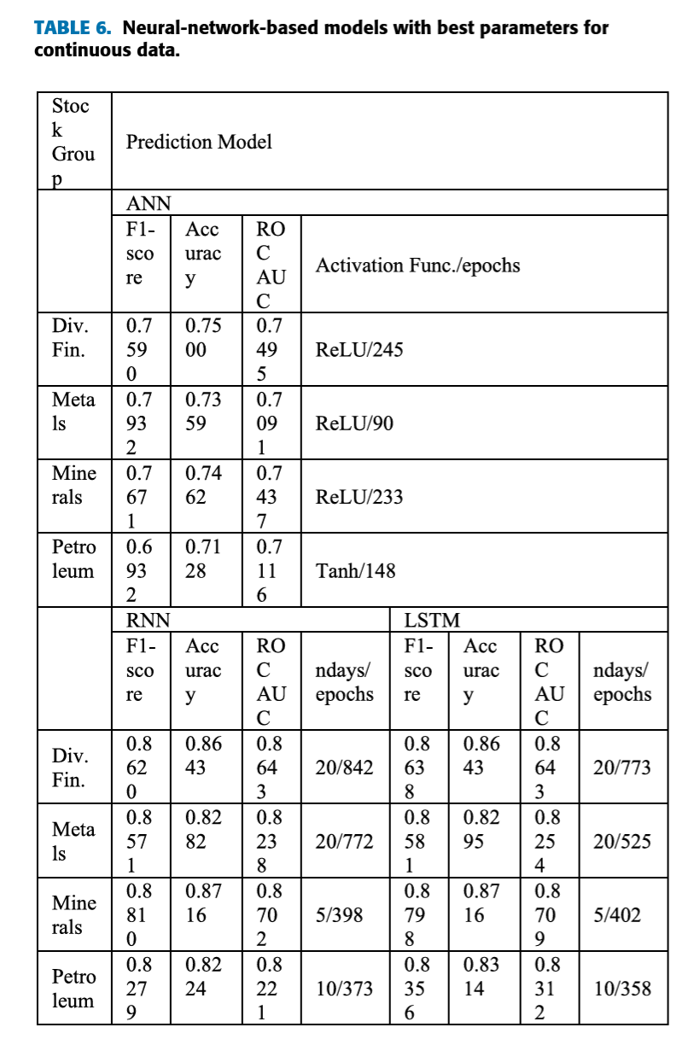

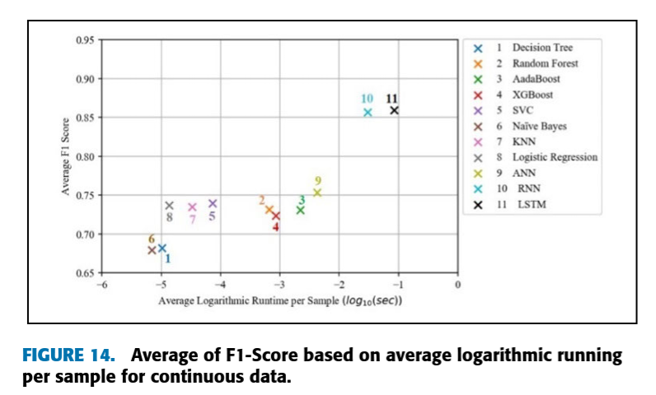

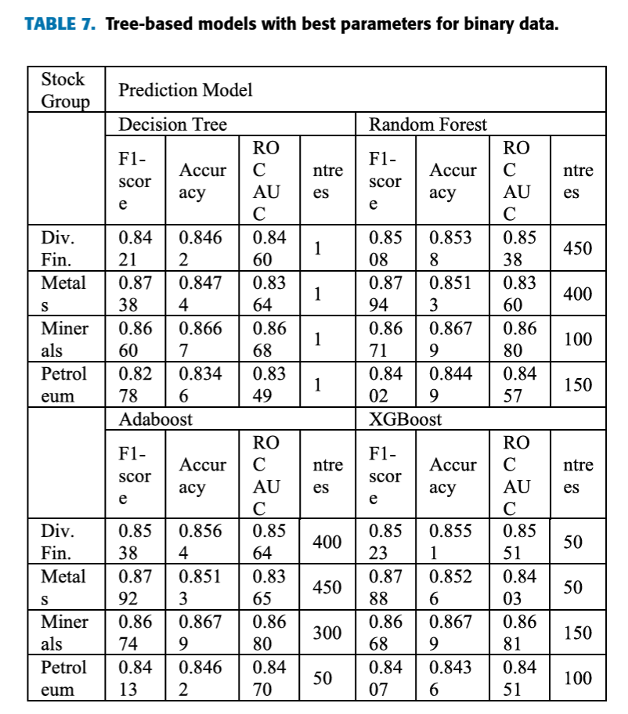

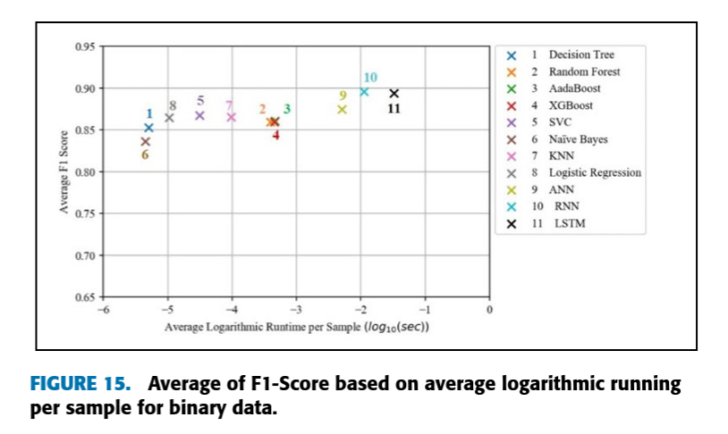

**Scope for Further Learning**

* **Explore Additional Technical Indicators:** Investigate the impact of other technical indicators that might improve prediction accuracy.
* **Incorporate External Factors:** Consider incorporating external factors such as news sentiment, economic indicators, and geopolitical events to enhance model performance.
* **Evaluate Other Deep Learning Architectures:** Explore the potential of different deep learning architectures (e.g., Transformer models) for stock market prediction.
* **Hybrid Approaches:** Combine machine learning and deep learning techniques to leverage their respective strengths.
* **Ensemble Methods:** Experiment with ensemble methods (e.g., stacking, bagging) to further improve prediction accuracy.
* **Real-Time Predictions:** Develop models capable of making real-time predictions based on streaming data.
* **Risk Assessment:** Incorporate risk assessment measures to quantify the uncertainty associated with predictions.
* **Explainability:** Explore techniques to interpret and explain the predictions made by the models.

**Conclusion**

The study highlights the effectiveness of machine learning and deep learning algorithms in predicting stock market trends. By leveraging historical data and advanced techniques, investors can gain valuable insights to inform their investment strategies. Future research can delve into the areas mentioned above to further enhance the accuracy and applicability of stock market prediction models.

**References and Citations**

1. CNN based Image Quality Classification - Neural Networks: [Link](https://drive.google.com/file/d/1S5XEeCdtzRt6zI_apkY5hyjNnAfZrKm1/view?usp=sharing)

G. -H. Gwon, J. H. Lee, I. -H. Kim and H. -J. Jung, "CNN-Based Image Quality Classification Considering Quality Degradation in Bridge Inspection Using an Unmanned Aerial Vehicle," in IEEE Access, vol. 11, pp. 22096-22113, 2023, doi: 10.1109/ACCESS.2023.3238204.

keywords: {Inspection;Image quality;Autonomous aerial vehicles;Distortion;Degradation;Convolutional neural networks;Convolutional neural networks;image quality classification;bridge inspection;unmanned aerial vehicle;motion blur;underexposure;overexposure},

2. Customer Service Optimization - Fuzzy Logic: [Link](https://drive.google.com/file/d/1L2iXqT20k2L0QUPRXAlJjiRWv-CCL1BX/view?usp=sharing)

Marín Díaz, G.; Carrasco González, R.A. Fuzzy Logic and Decision Making Applied to Customer Service Optimization. *Axioms* **2023**, *12*, 448. <https://doi.org/10.3390/axioms12050448>

3. Predicting Stock Market Trends - Machine Learning and Deep Learning: [Link](https://drive.google.com/file/d/1PFrMH91MMga0Fsj9UiHkk26pWuPYSPka/view?usp=sharing)  
M. Nabipour, P. Nayyeri, H. Jabani, S. S. and A. Mosavi, "Predicting Stock Market Trends Using Machine Learning and Deep Learning Algorithms Via Continuous and Binary Data; a Comparative Analysis," in IEEE Access, vol. 8, pp. 150199-150212, 2020, doi: 10.1109/ACCESS.2020.3015966.

keywords: {Stock markets;Machine learning;Predictive models;Market research;Prediction algorithms;Support vector machines;Indexes;Stock market;trends prediction;classification;machine learning;deep learning},